SmartBridge SkillWallet
Let's Bridge the Gap A SmartBridge Product

Solution Architecture
Date | 30 June 2026
Team ID
Project Name | Smart Lender
Maximum Marks | 5 Marks

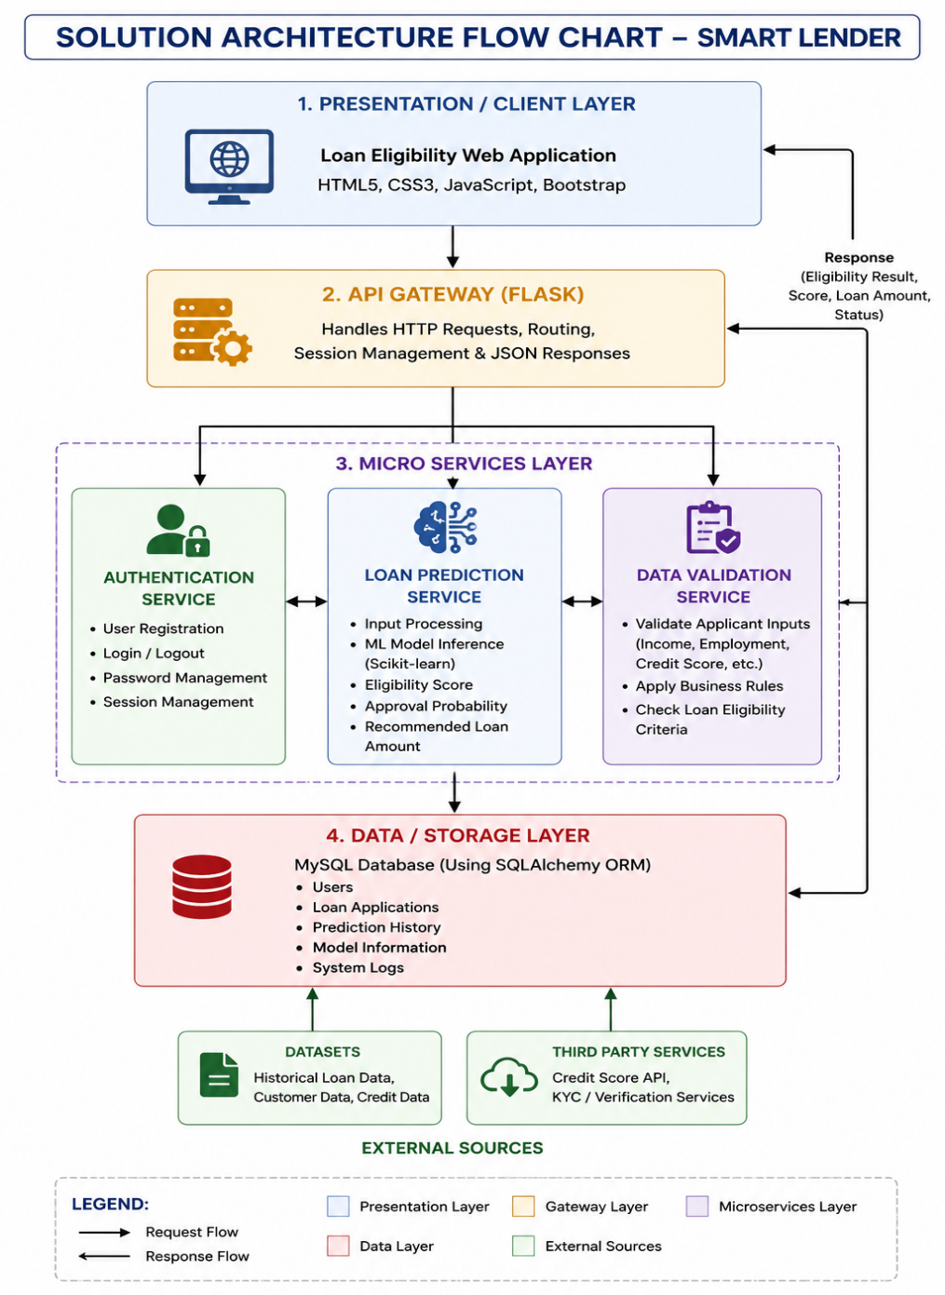
Solution Architecture Diagram

Component Description Table
